1. Which are the top three variables in your model which contribute most towards the probability of a lead getting converted?

Ans:-

Based on coefficient values from model 4, top 3 contributors are

* 1. Total Time Spent on Website
  2. LeadOrgin_Lead Add Form
  3. NotableActivity_Had a Phone Conversation

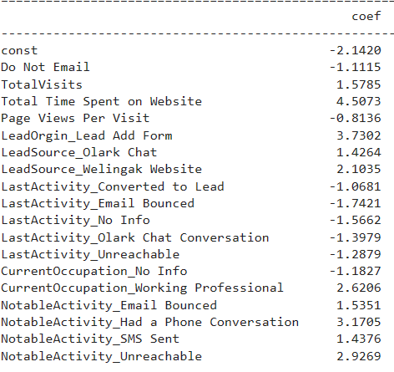

1. What are the top 3 categorical/dummy variables in the model which should be focused the most on in order to increase the probability of lead conversion?

Ans-

Again from model 4, top 3 category which should be focused most are

* 1. LeadOrgin_Lead Add Form
  2. NotableActivity_Had a Phone Conversation
  3. NotableActivity_Unreachable

1. 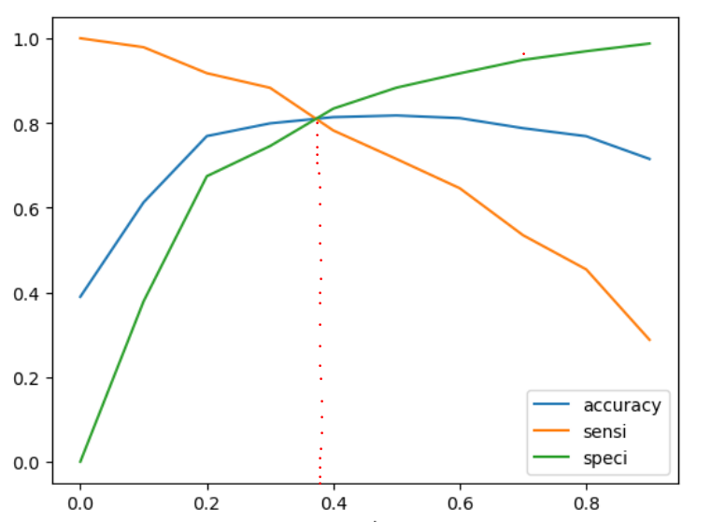X Education has a period of 2 months every year during which they hire some interns. The sales team, in particular, has around 10 interns allotted to them. So during this phase, they wish to make the lead conversion more aggressive. So they want almost all of the potential leads (i.e. the customers who have been predicted as 1 by the model) to be converted and hence, want to make phone calls to as much of such people as possible. Suggest a good strategy they should employ at this stage.  
   Ans:-

From the accuracy, sensitivity, specificity cut-off, we found probability to be considered for final prediction is 0.37

So, to gain maximum lead conversion, X-Education has to reach all leads which are from model 4’s final predicted columns which have conversion probability 1 under the cut off of 0.37. i.e. lead score more than 37.

As each lead has been assigned a lead score, so during the given period of 2 months, X Education can consider including leads having slightly lower lead score, for e.g 30, in order to increase the bucket of hot leads and at the same time focus on tacking the leads with lower lead score but have shown some traits from the variables contributing most towards the probability of conversion. For e.g, a lead has lower lead score but has spent considerable amount of time on website etc.

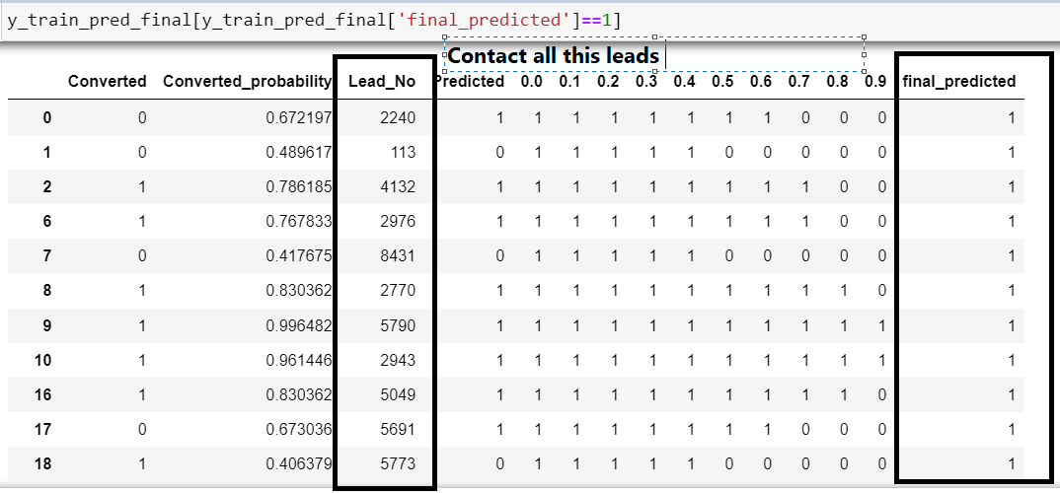

1. Similarly, at times, the company reaches its target for a quarter before the deadline. During this time, the company wants the sales team to focus on some new work as well. So during this time, the company’s aim is to not make phone calls unless it’s extremely necessary, i.e. they want to minimize the rate of useless phone calls. Suggest a strategy they should employ at this stage.

Ans :-

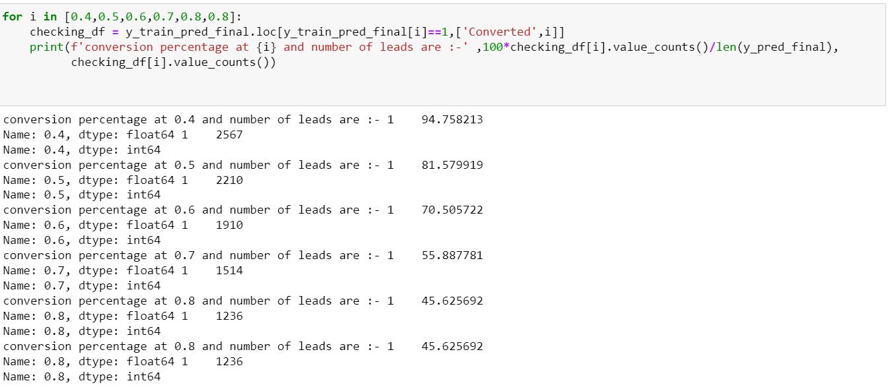

From above picture we can get the conversion probabilities as 0.4,0.5,0.6,0.7, 0.8 cut-off values as 94.75%,81.57%,70.50%,55.88%,45.62%,45.62%. And number of leads respectively are 2567, 2210, 1910, 1514, 1236, and 1236. So as company target is already achieved, at cut-off value of 0.7, we can reach out to 1514 leads still achieves 55.88% conversion rate.

So, during this stage, X Education should focus on,

* Leads having higher lead score
* Leads who have spent more time on website
* Leads that have origin as lead add form
* Leads which are identified as working professionals as they have higher conversion rate.